# OLE DB Command Transformation in SSIS

**SSIS Slowly Changing Dimension**

# OLE DB Command Transformation in SSIS

OLE DB Command Transformation in [SSIS](https://www.tutorialgateway.org/ssis/) is used to run the SQL statements like [INSERT](https://www.tutorialgateway.org/sql-insert-statement/), [UPDATE](https://www.tutorialgateway.org/sql-update-statement/), and [DELETE](https://www.tutorialgateway.org/sql-insert-statement/) statements in the Data Flow. Please refer to [Delete Data Using OLEDB Command Transformation](https://www.tutorialgateway.org/delete-data-using-oledb-command-transformation-in-ssis/) article to understand how to delete data using SSIS OLE DB Command Transformation and [Update Data using OLEDB Command Transformation](https://www.tutorialgateway.org/update-data-using-oledb-command-transformation-in-ssis/)article to understand the Update operations.

Drag and drop the Data Flow Task from the toolbox to the control flow region. And rename it as Inserting Data using OLE DB Command Transformation in SSIS.

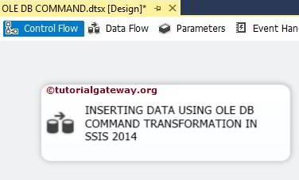

Double click on it, and it will open the data flow tab.

Drag and drop OLE DB Source and OLE DB Command transformation from the toolbox to the data flow region.

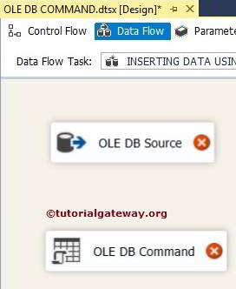

Within the data flow region, Double click on OLE DB source will open the connection manager settings and allows us to select the required table.

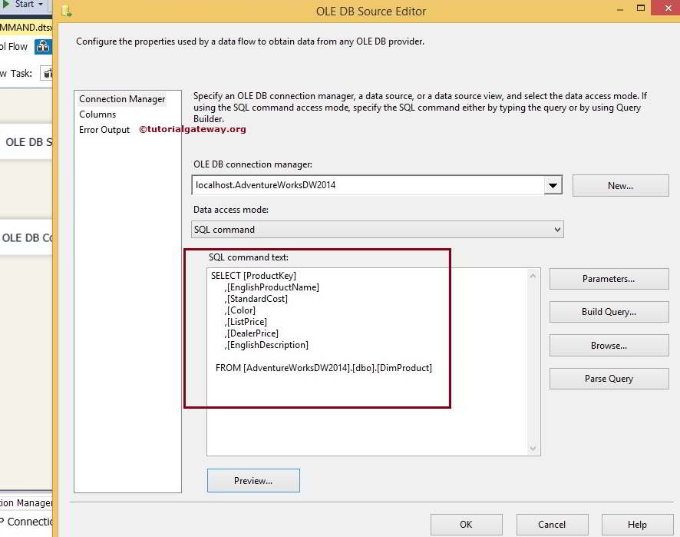

The [SQL](https://www.tutorialgateway.org/sql/) Command we used in the above screenshot is

SELECT [ProductKey]

,[EnglishProductName]

,[StandardCost]

,[Color]

,[ListPrice]

,[DealerPrice]

,[EnglishDescription]

FROM [AdventureWorksDW2014].[dbo].[DimProducts]

Click on the columns tab to verify the columns. In this tab, we can uncheck the unwanted columns.

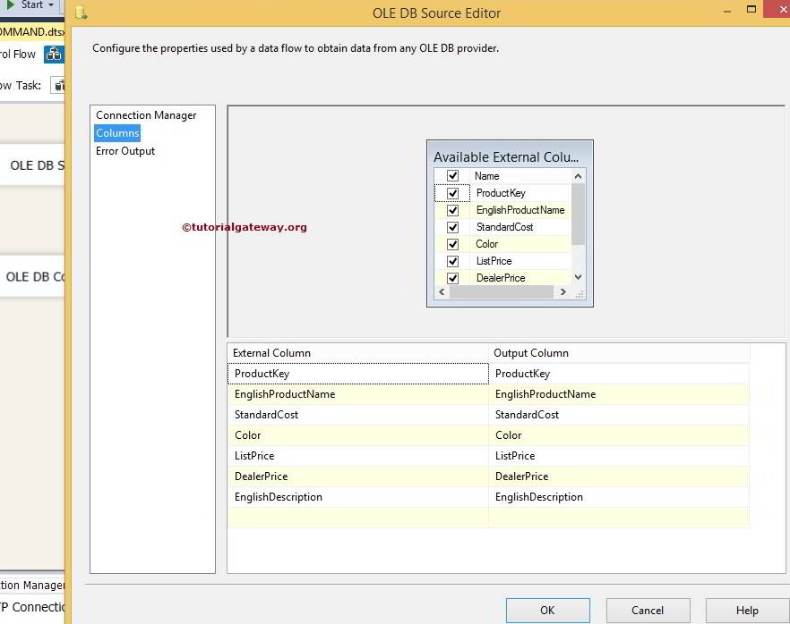

Drag the OLE DB Source Output arrow on to the OLE DB Command Transformation to perform transformations on the source data.

**STEP 5:** Double click on the OLE DB Command Transformation will open the Advanced Editor for OLE DB Command to configure it.

Within the **Connection Managers** tab, we are selecting the already created OLE DB Connection from the list. Please refer to the [OLE DB Connection Manager in SSIS](https://www.tutorialgateway.org/ole-db-connection-manager-in-ssis/) article to understand the configuration settings.

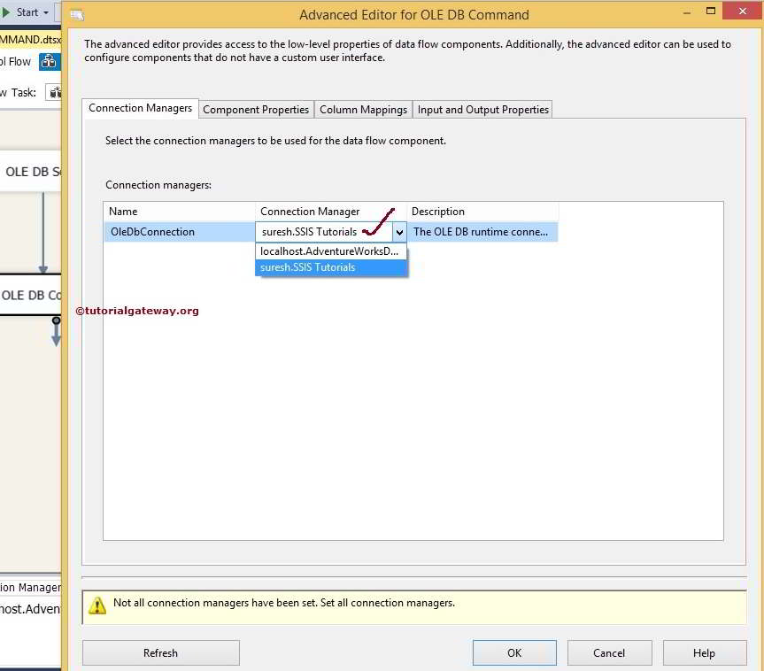

Within the **Component Properties,**we have to write the SQL Statement we have to perform. Please select the **SqlCommand** property and click on the browse button (**…** button)

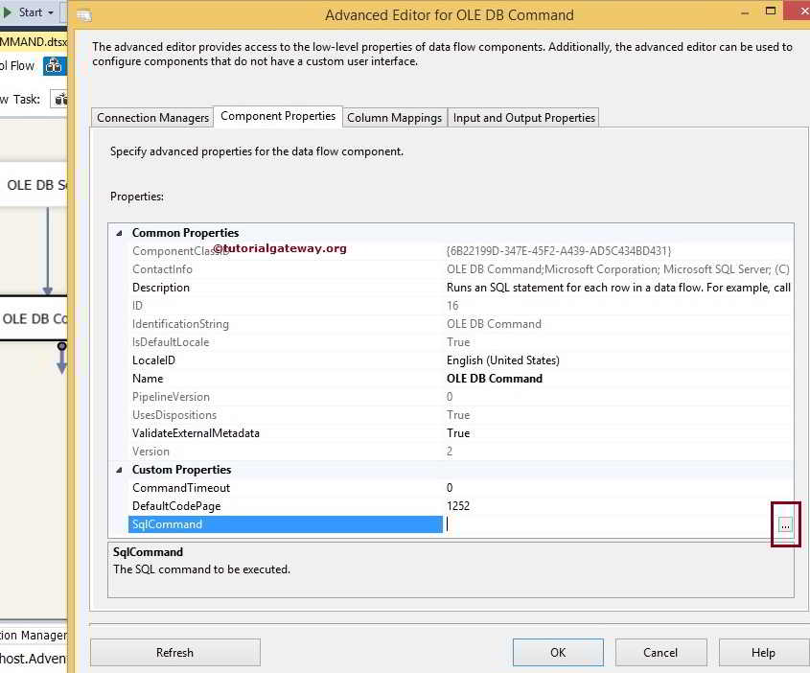

Once you click on the browse button, a **String Value Editor** window opened to write the SQL Statement. In this example, we are inserting the values into the products table.

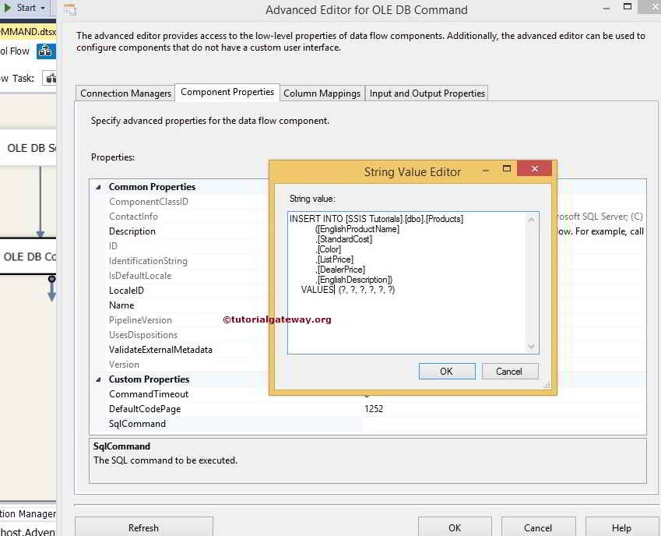

SQL Statement we used in for this Ole DB Command Transformation in SSIS is

INSERT INTO [SSIS Tutorials].[dbo].[Products]

([EnglishProductName]

,[StandardCost]

,[Color]

,[ListPrice]

,[DealerPrice]

,[EnglishDescription])

VALUES

(?, ?, ?, ?, ?, ?)

Within the Column Mapping, we have to assign the appropriate column name to the parameters.

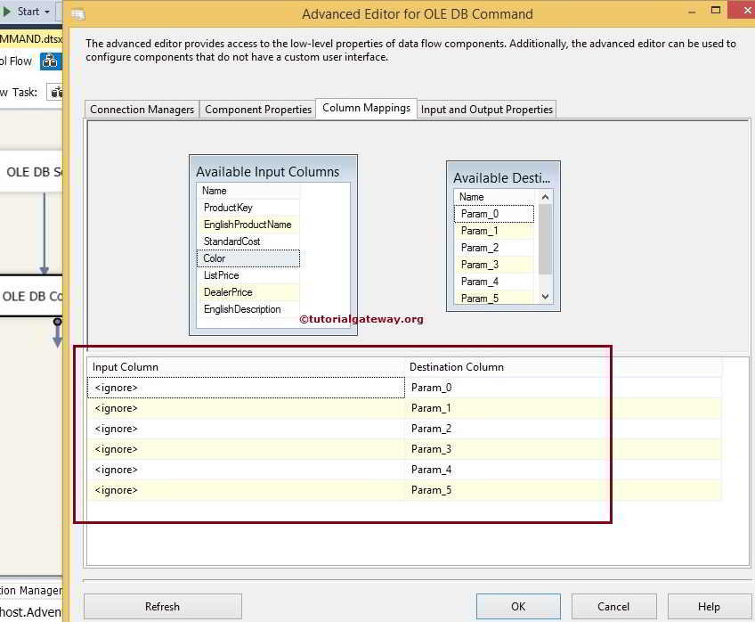

From the above screenshot, you can observe that Param_0 represents the first question mark, and param_5 represents the fifth question mark.

Let’s assign the appropriate column names to the parameters.

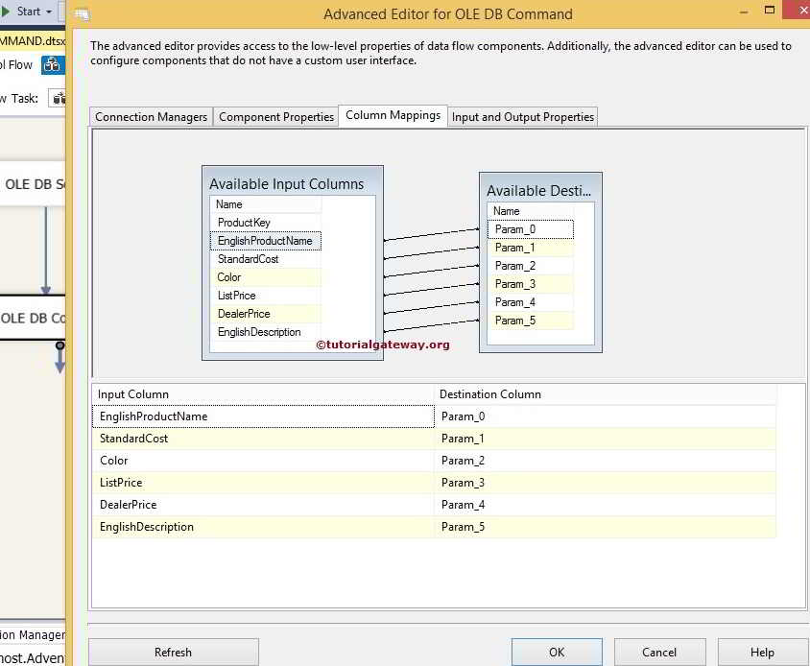

Click OK to finish configuring the Inserting Data Using OLE DB Command Transformation in the SSIS package. Let us Run the package

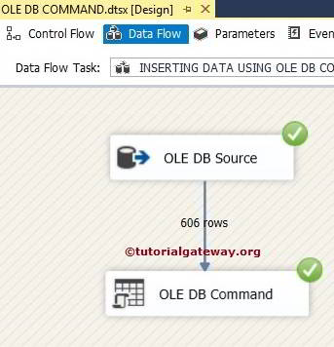

Let us open the [SQL Server Management Studio](https://www.tutorialgateway.org/sql/) and check the result

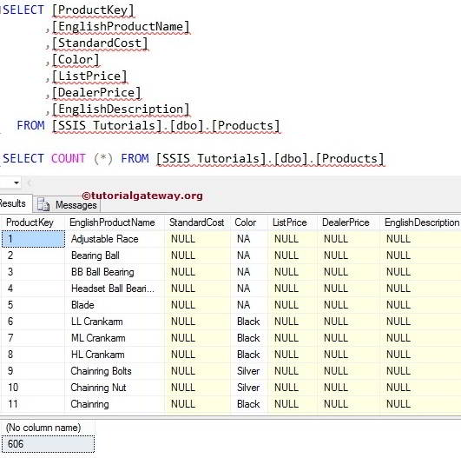

**SSIS Slowly Changing Dimension Type 0**

In this article, we will explain about SSIS Slowly Changing Dimension Type 0 (called as a Fixed attribute).

**SSIS Slowly Changing Dimension Type 0:** If you want to restrict the columns to be unchanged, then mark them as a Fixed attribute. If your Dimension table members (Columns) marked as Fixed attributes, then it will not allow any changes to those columns (Updating Data) but, you can insert new records. This type of change is useful. For example, we can mark the Employee Last Name, date of birth, Company Login details as fixed attributed because once we store those values, they won’t change for any employee. Before we step into the example, let us see the data inside our Dimension table.

The following screenshot will show you the data inside our [DimCustomer] table. You can get the same data by selecting TOP 10 records from [DimCustomer] table in [AdventureWorksDW2014] database.

## SSIS Slowly Changing Dimension Type 0 example

**STEP 1:** Open BIDS and Drag and drop the data flow task from the toolbox to control flow and name it as SSIS Slowly Changing Dimension Type 0.

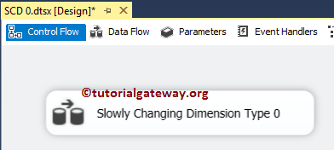

Double click on it will open the data flow tab.

**STEP 2:** Drag and drop OLE DB Source, Slowly Changing Dimension from [SSIS](https://www.tutorialgateway.org/ssis/) toolbox to data flow region

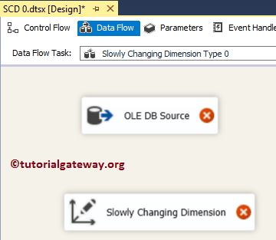

**STEP 3:** Double click on OLE DB source in the data flow region will open the connection manager settings and provides space to write our SQL statement. Here we are using already created [OLE DB Connection Manager](https://www.tutorialgateway.org/ole-db-connection-manager-in-ssis/) and CustomerSource table present in the [SSIS Source] as the Source table. Please refer [OLE DB Source in SSIS](https://www.tutorialgateway.org/ole-db-source-in-ssis/) article.

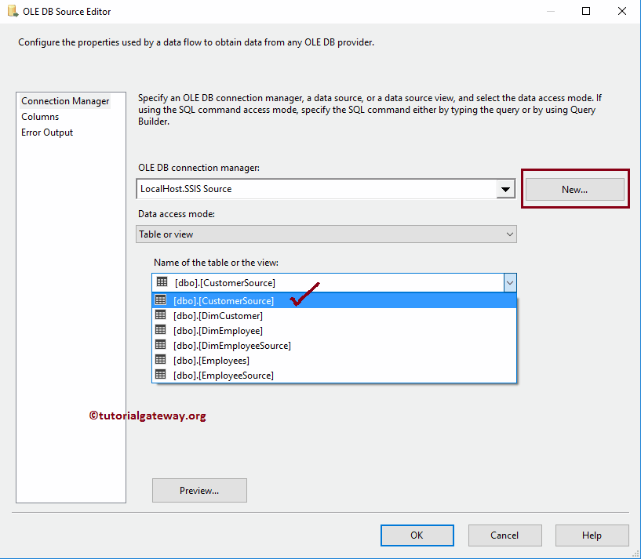

**STEP 4:** Click on the columns tab to verify the columns. In this tab, we can uncheck the unwanted columns also.

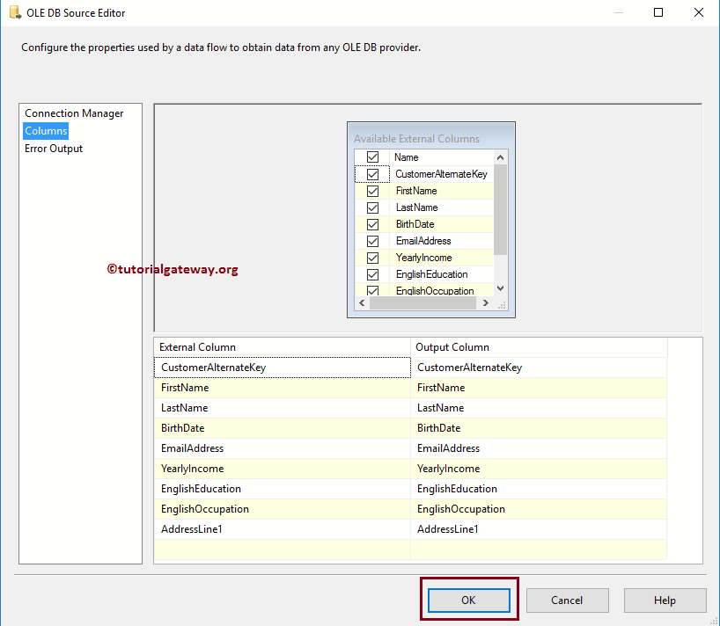

Drag and drop the blue arrow from OLE DB Source to Slowly Changing Dimension Transformation to connect the data.

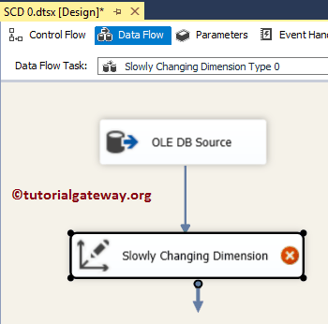

**STEP 5:** Double-click the Slowly Changing Dimension transform to open the editor. Once you click on it, It will open Slowly Changing Dimension Wizard. The first page is welcome page, and If you don’t want to see this page again, please tick the checkbox **“Do not show this page again”**. For now, click Next

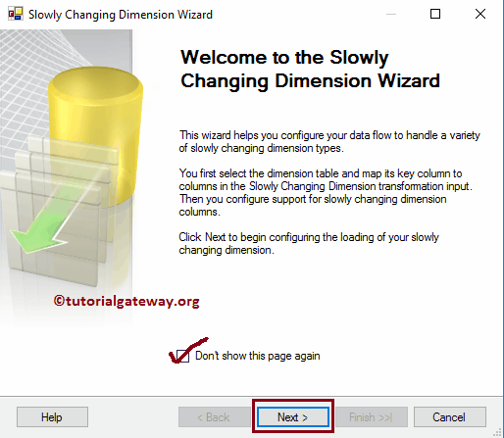

**STEP 6: Select a Dimension Table and Keys:** This page is used to configure the Dimensional table information.

**Connection Manager:** This option is used to provide a connection to the dimension table. Here we are using already created [OLE DB Connection Manager](https://www.tutorialgateway.org/ole-db-connection-manager-in-ssis/) and DimCustomer table present in the [SSIS Source] as the dimension table. You always have the luxury to change the connection by clicking the New button.

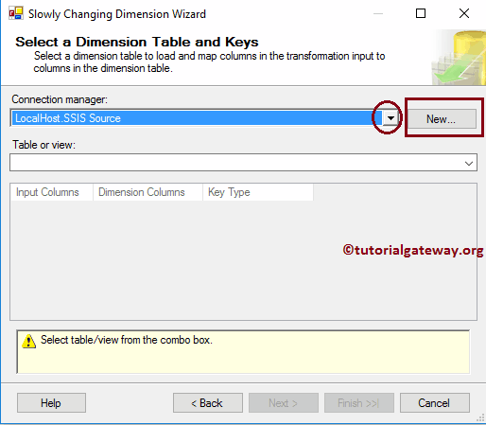

**Table or View:**This option is useful to select the Data Warehouse Dimension table or View on which you want to perform slowly changing operation. Here we are selecting the DimCustomer table.

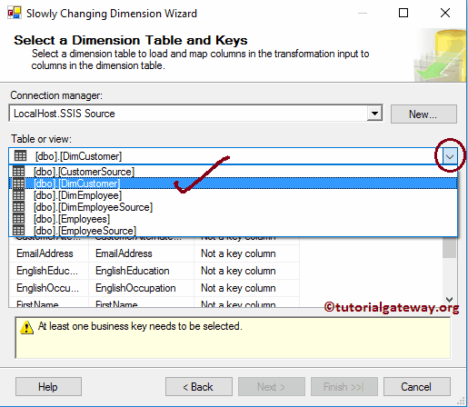

* **Input Columns:** Columns that are coming from the OLE DB Source Or column that you want to insert or update.
* **Dimension Columns:**Columns that are available in the Dimension table.
* **Key Type:** To perform Slowly Changing Dimension, we need at least one Business key, and we all know that the Customer Alternative Key is the key column. Please change the Key type from **Not a Key Column** to **Business key**

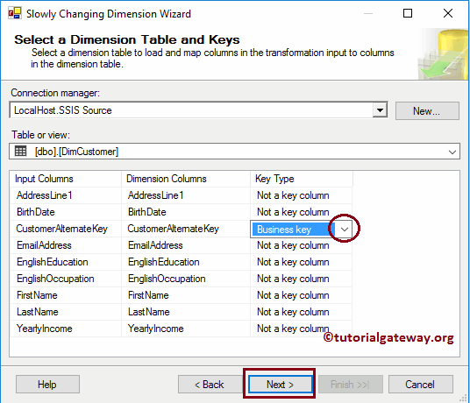

**STEP 7 – Slowly Changing Dimension Columns:** This is the main page in this whole wizard. here we have

* **Dimension Columns:**All the columns that are available in the Dimension table will be available in this section. Here you have to select the columns that you want to mark as a fixed attribute. From the below screenshot you can observe that we are choosing the Last Name, Birthdate and Email Address columns
* **Change Type:** Select the change type. In this example, we are discussing SCD Type 0. So, we are keeping the default Fixed attribute as change type.

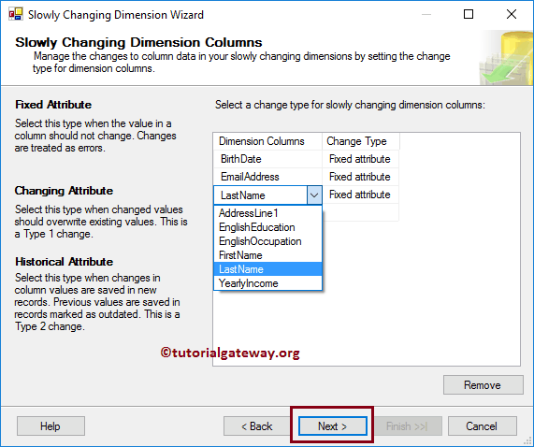

By default, the wizard will assign the Fixed attribute as the Change Type. But you can change them.

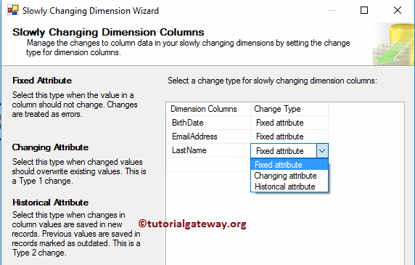

**STEP 8 – Fixed and Changing Attribute Options:**This page has two options, and the second option is grayed out for SCD Type 0. If there are any changes in the data (Dat coming from the input column is different from Dimension table data) then:

* If you want to Fail the package, then checkmark the **Fail the transformation if changes are detected in a fixed attribute** option.
* If you don’t want to fail the package, unchecked this option. Note, unchecking this option doesn’t allow you to update the existing records but it will not fail the package

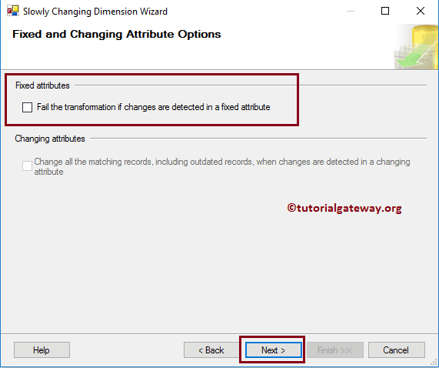

**STEP 9 – Inferred Dimension Members:**We will discuss this option in the Slowly Changing Dimension Inferred Dimension article. For now, we are de-selecting this option and click Next button

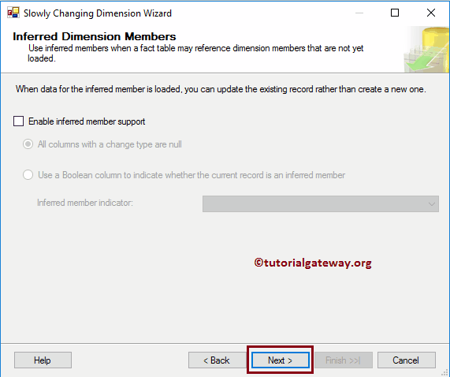

**STEP 10 – Finish the Slowly Changing Dimension Wizard:**Click finish button to finish configuring the SSIS Slowly Changing Dimension Type 0

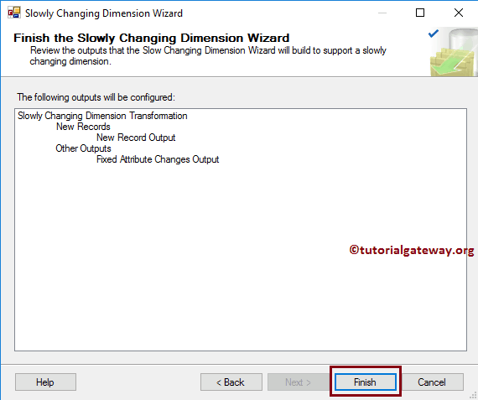

Once you click on the finish button, our Data Flow will automatically change. If you observe the below screenshot, it added the [OLE DB Destination](https://www.tutorialgateway.org/ssis-ole-db-destination/) to insert new records into the Dimension table

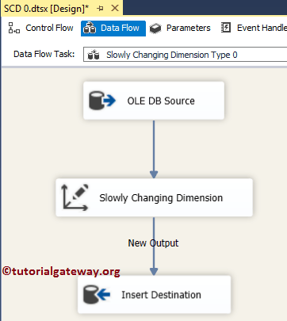

**(Optional Step):** Let us double-click on the OLE DB Destination to check the automatically created destination (table name and connection manager setting and mappings).

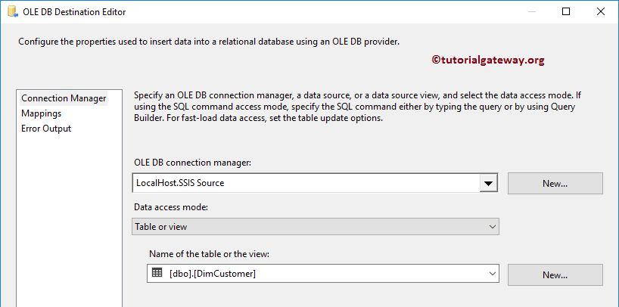

Click OK to finish our SSIS Slowly Changing Dimension Type 0 package design. Let us run the package

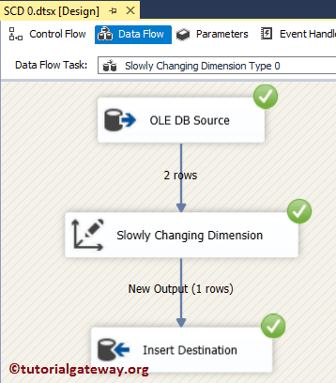

From the above screenshot, you can observe that, though two rows are coming from the OLE DB Source. Only one row inserted (No update performed) here.

Let’s open the [SQL Server Management Studio](https://www.tutorialgateway.org/sql/) and check the results. If you observe the below records, our package added New record of customer Alternative key AW00011011. But it didn’t update the Last name of AW00011001.

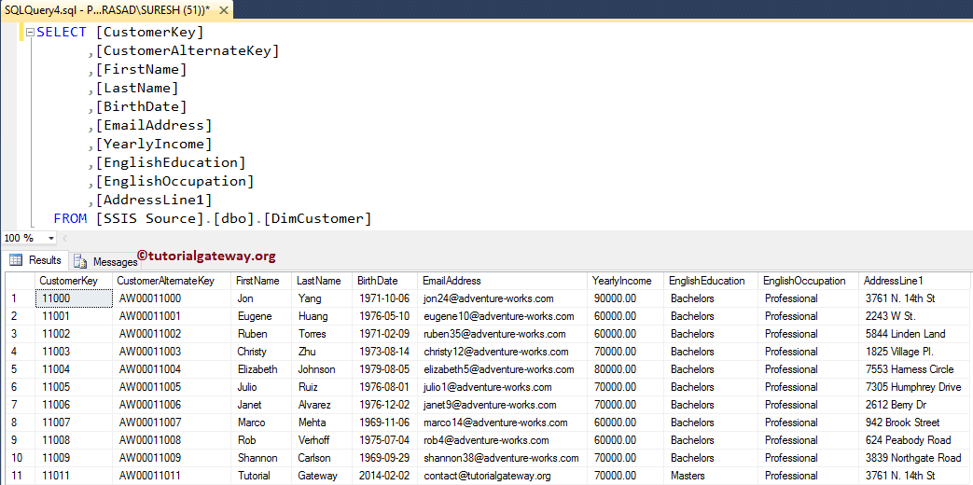

Let us see what will happen when we uncheck the **Fail the transformation if changes are detected in a fixed attribute** option.

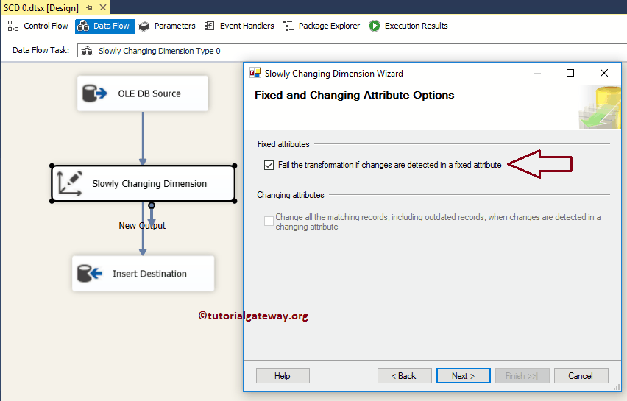

Click OK to finish the SSIS Slowly Changing Dimension Type 0 package design and let us run the package. From the below screenshot, you can observe that the package has failed at Slowly Changing Dimension transformation.

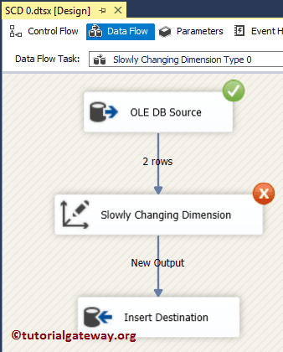

# Character Map Transformation in SSIS

Character Map Transformation in SSIS is useful to transform input characters. If we want to change our string columns to Upper Case, Lower case, Simplified Chinese, Katakana, Hiragana, and Traditional Chinese, then SSIS character map transformation do the trick for you. It gives you the option to select whether you want to override the existing column with output result, or you want to add it as a new column.

Character Map Transformation in [SSIS](https://www.tutorialgateway.org/ssis/) supports 10 types of operations. The operations and the description is displayed below.

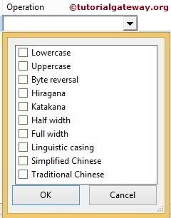

1. **Lowercase:** Converts the string column characters to lowercase. For instance, TutorialGateway column converted into tutorialgateway
2. **Uppercase:** Converts the string column characters to uppercase. For example, TutorialGateway column turns into TUTORIALGATEWAY
3. **Bye Reversal:** This SSIS Character Map Transformation reverses the bytes order of the Unicode
4. **Hiragana:** Converts Katakana characters to Hiragana characters.
5. **Katakana:** Converts Hiragana characters to Katakana characters.
6. **Half Width:** Converts Full-width characters to Half-width characters. For instance, **ｈｅｌｌｏ** converted to hello.
7. **Full Width:** This SSIS Character Map Transformation converts Half-width characters to Full-width characters. For instance, hello is converted to ｈｅｌｌｏ
8. **Linguistic casing:** In general database uses its system language to store the data into columns. For example, my system stores date in English US format because it is my system’s local language. To use other regional languages, then we can use this Linguistic casing option
9. **Simplified Chinese:** This SSIS Character Map Transformation Converts traditional Chinese characters to simplified Chinese characters. For instance, how are you in Simplified Chinese is 你好吗
10. **Traditional Chinese:** Converts simplified Chinese characters to Traditional Chinese characters.

Character Map Transformation in SSIS allows us to select more than one option for a single column. However, there are some restrictions during selection. For instance, if we choose the lowercase operation, then there is no point in selecting the uppercase also. The below table shows the actions we should not select on a single column.

|  |  |
| --- | --- |
| **SELECTED OPERATION** | **OPERATIONS SHOULD NOT SELECT** |
| Lowercase | Uppercase, Hiragana, Katakana, Half Width and Full Width |
| Uppercase | Lowercase, Hiragana, Katakana, Half Width and Full Width |
| Hiragana | Katakana, Lowercase, Uppercase |
| Katakana | Hiragana, Lowercase, Uppercase |
| Half Width | Full Width, Lowercase, Uppercase |
| Full Width | Half Width, Lowercase, Uppercase |
| Simplified Chinese | Traditional Chinese |
| Traditional Chinese | Simplified Chinese |

## Character Map Transformation in SSIS Example

**STEP 1:** Drag and drop the data flow task from the toolbox to control flow and change the name as Character Map Transformation in SSIS.

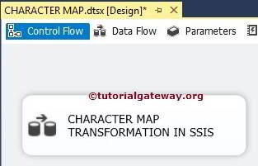

Double click on it will open the data flow tab.

**STEP 2:** Drag and drop [OLE DB Source](https://www.tutorialgateway.org/ole-db-source-in-ssis/), CHARACTER MAP Transformation, and ADO.NET Destination into the data flow region

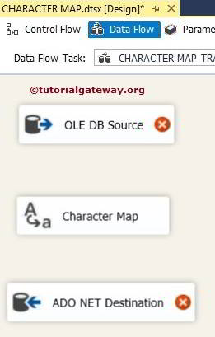

**STEP 3:** Double click on OLE DB source in the data flow region will open the connection manager settings and provides space to write our [SQL](https://www.tutorialgateway.org/sql/) statement.

For the time being, we had selected [First Name], [Last Name], and [Email ID] from DimEmployees table present in the [Adventure Works DW 2014] database.

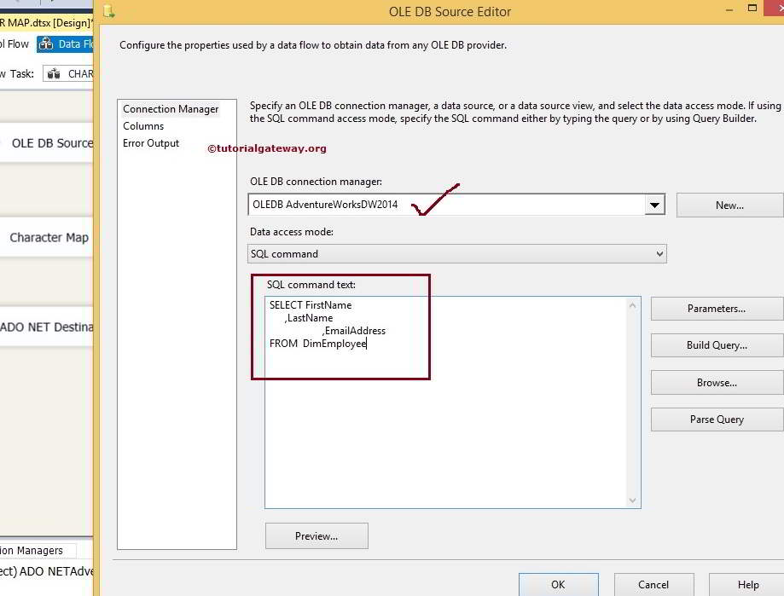

[SQL](https://www.tutorialgateway.org/sql/) Command we used in the above screenshot is:

USE AdventureWorksDW2014

GO

SELECT FirstName

,LastName

,EmailAddress

FROM DimEmployee

**STEP 4:** Click on the columns tab to verify the columns. In this tab, we can uncheck the unwanted columns also.

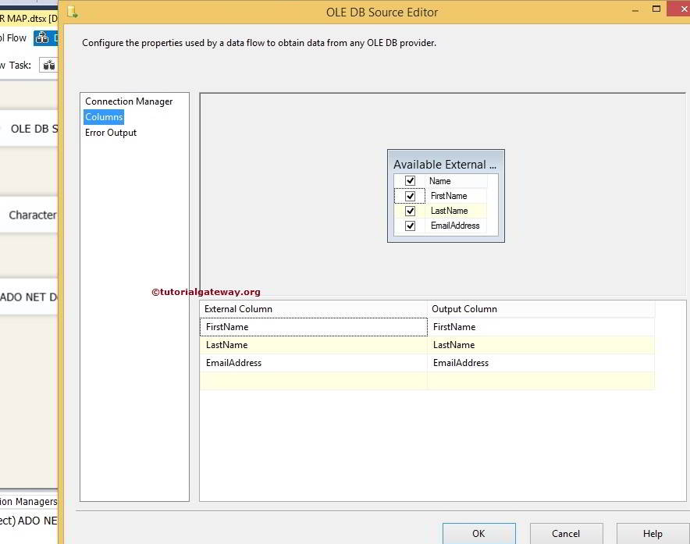

**STEP 5:** Click ok and connect the output arrow of OLE DB Source to Character Map Transformation.

Double click on the SSIS Character Map Transformation to configure it

* **Input Column:** Whatever we selected in the **Available Input Columns** option automatically reflect in this option. We can also directly select the input column here itself.
* **Destination:** We have an option to select, Whether we want to replace the original column. Or we want to add this as a new column. In this example, we are using the New column option.
* **Operation:**We already discussed above
* **Output Alias:**Specify the new column name. It acts the same as [ALIAS column](https://www.tutorialgateway.org/sql-alias/) in [SQL](https://www.tutorialgateway.org/sql/)

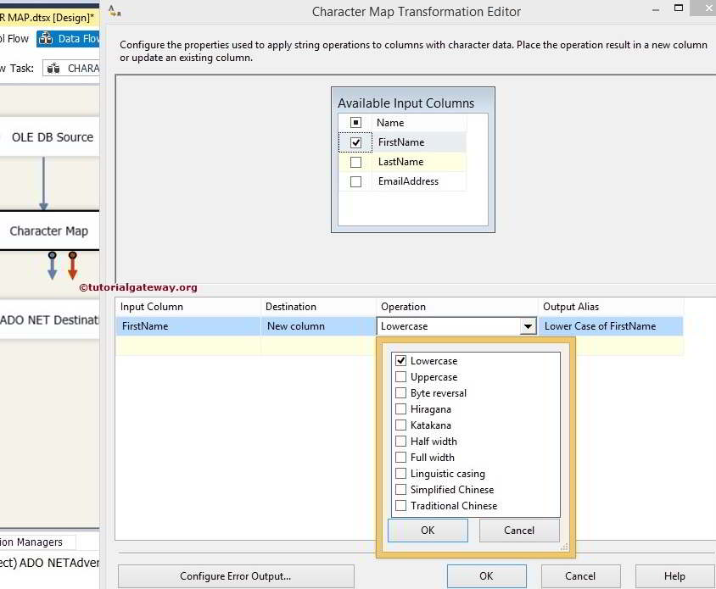

For the time being, we are using only Upper and Lower. However, you can try all the available options in SSIS character map transformation. Click ok.

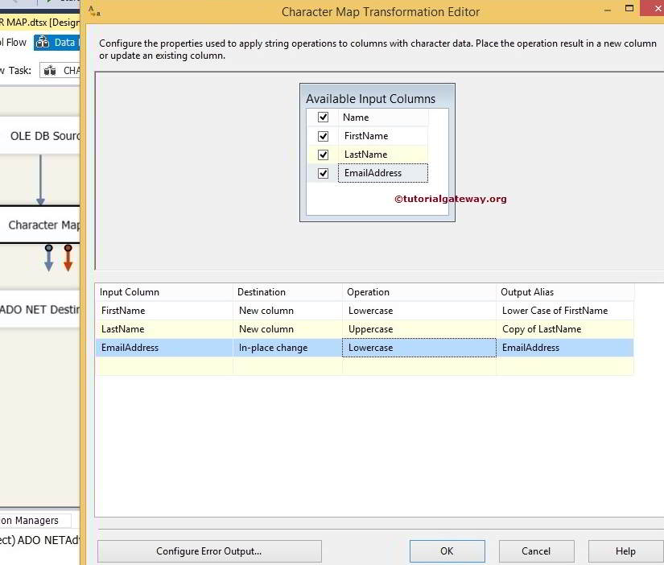

**STEP 6:** Now, we have to provide the Server, database, and table details of the destination. So double-click on the ADO.NET Destination and provide the required information

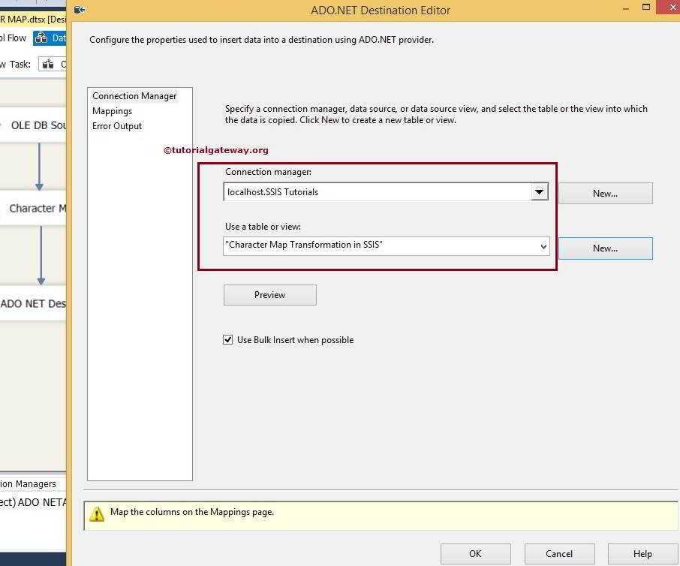

Here we are selecting the Character Map Transformation in SSIS table from SSIS Tutorials Database

**STEP 7:** Click on the Mappings tab to check whether the source columns accurately mapped to the destination columns.

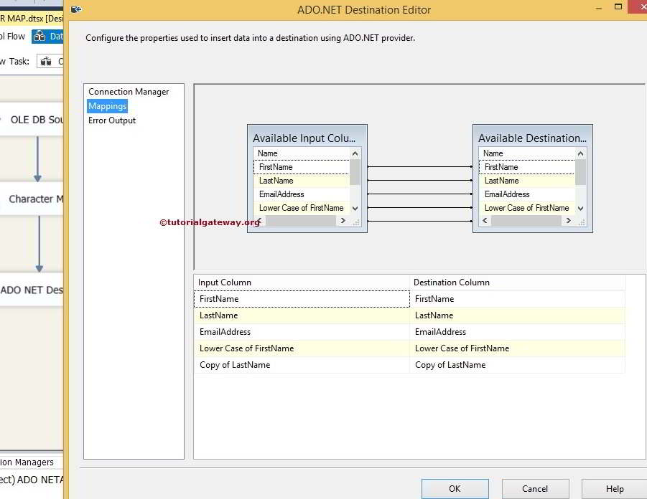

**NOTE:**If your input column names and destination column names are the same, the intelligence automatically maps. If there are any changes in the column names (any alias or calculated columns), we have to map them manually.

By clicking ok, we finished our SSIS Character Map Transformation package. Let us run the package

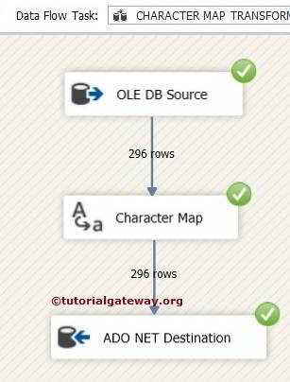

Let us open the [SQL](https://www.tutorialgateway.org/sql/) Query window to Preview the data

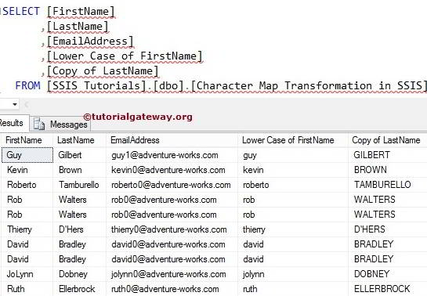

# Cache Transformation in SSIS

Cache Transformation in SSIS is used to read data from a wide variety of sources such as flat files, Excel sheets, and ADO.NET data sources. And then save data from those data sources in .caw file.

By default, the [Lookup Transformation in SSIS](https://www.tutorialgateway.org/lookup-transformation-in-ssis/) uses the OLE DB Connection Manager for the lookup reference table. We can use other sources also, but they must be used indirectly via SSIS Cache Transformation.

In real-time, We use the SSIS Cache Transformation to save the reference table in .caw format. Then perform Lookup transformation using the [Cache Connection Manager](https://www.tutorialgateway.org/cache-connection-manager-in-ssis/) in [SSIS](https://www.tutorialgateway.org/ssis/).

## Cache Transformation in SSIS Example

In this example, we are going to use the SSIS Cache transformation to copy the data present in the Excel file to the cache file (.caw extension).

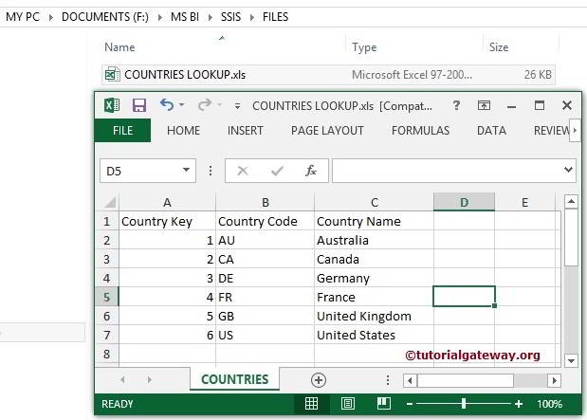

**STEP 1:** Drag and drop the data flow task from the toolbox to the control flow and rename it as Cache Transformation.

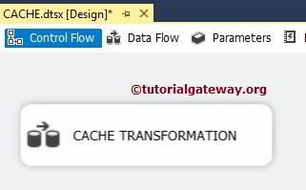

Double click on it opens the data flow tab.

**STEP 2:** Drag and drop Excel source from toolbox to data flow region. Double click on it to configure the excel file

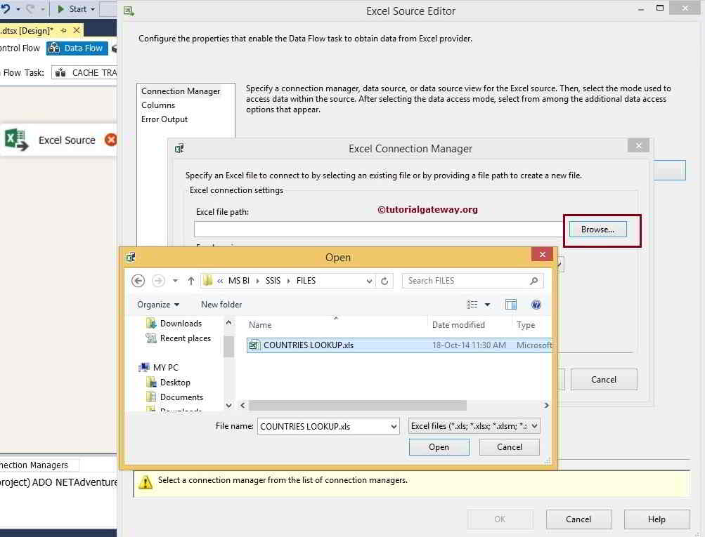

Click on the Browse button to select the source file from the local hard drive.

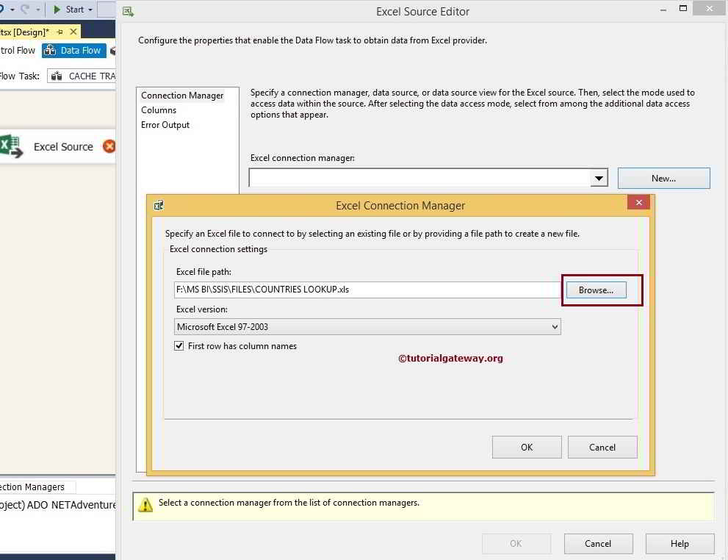

From the above screenshot, you can observe that we selected the COUNTRIES LOOKUP.xls file in local drive.

**NOTE:**If your Excel file contains column names in the first row, checkmark the **First Row has Column Names**option.

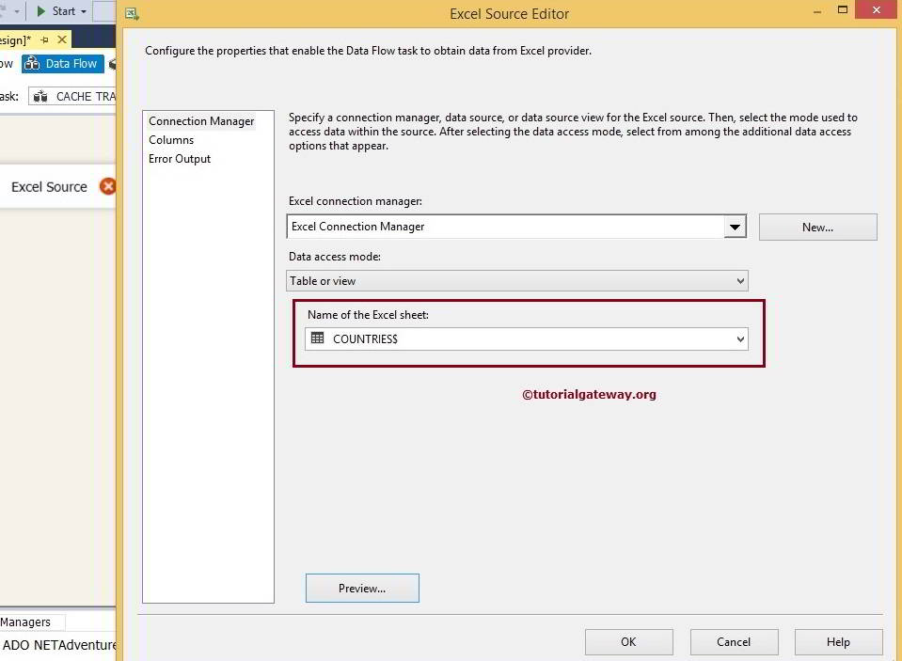

**STEP 3:** Click on the columns tab to verify the columns. In this tab, we can uncheck the unwanted columns.

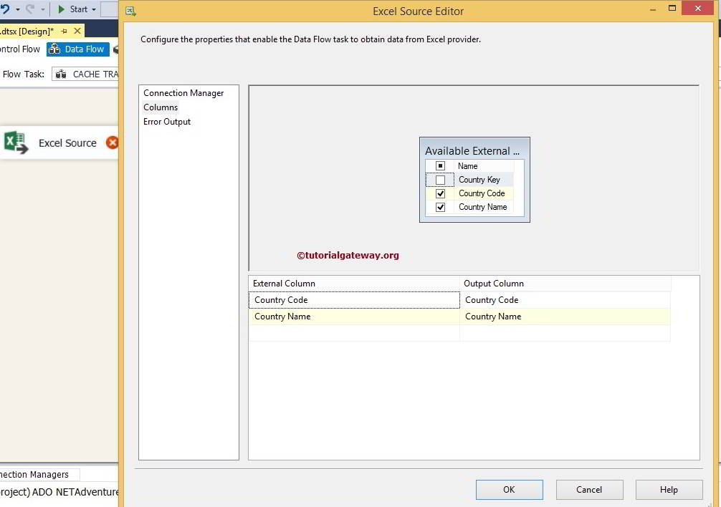

From the above screenshot, you can see that the Country Key unchecked because we have nothing to do with key columns. We only require the Country name to use as lookup column and Country code column as additional output column.

Drag the blue arrow from Excel Source to Cache Transformation to perform the transformation on the source data.

**STEP 4:** Double click on the SSIS Cache Transformation to configure it.

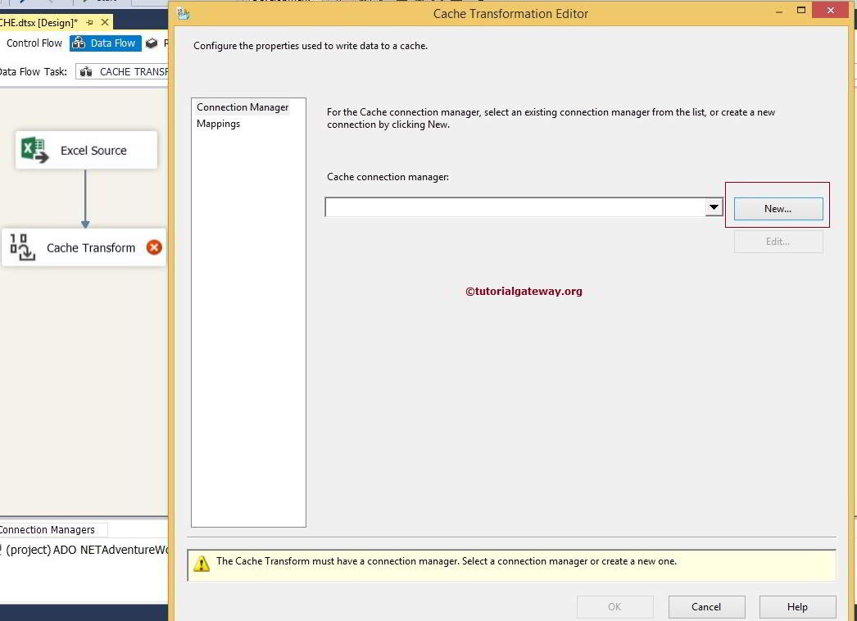

We haven’t created the SSIS Cache Connection Manager in this project before, Click on the new button to configure it.

**STEP 5:** On the General tab of the SSIS Cache Transformation Editor,

* **Connection Manager Name:** The Default value is Cache Connection Manager. But you can change the name of the connection manager as per the project requirement.
* **Description:** Provide a valid description for the Cache Connection Manager. But for now, we are leaving default here.
* **Use File Cache:** If you checkmark this option, the connection manager will write cached data to a file.
* **Browse:** This button is used to browse the existing file or creating a new file of extension .caw

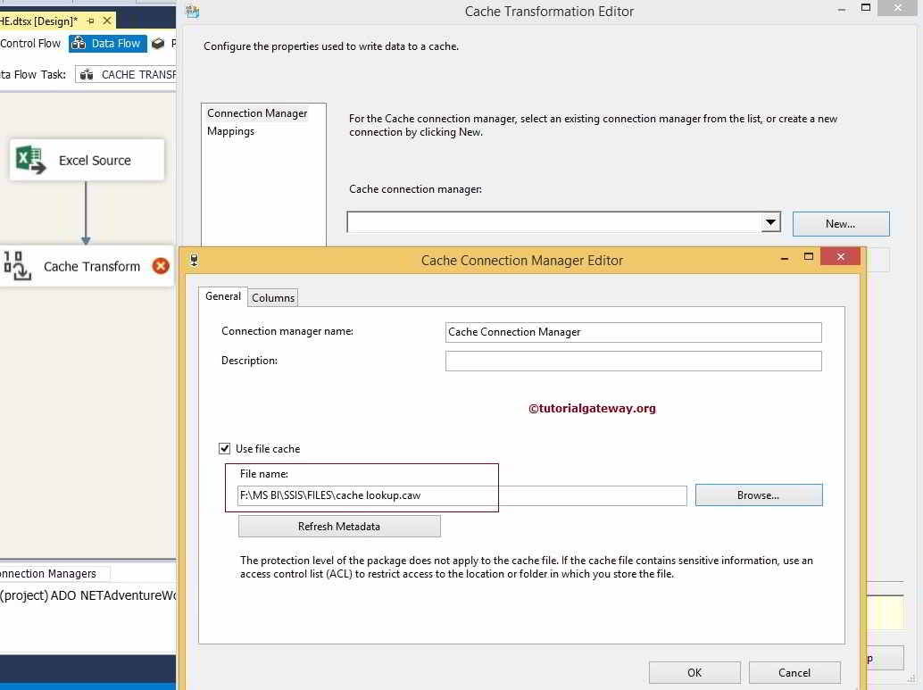

From the above screenshot, you can observe that We used the file cache option. Next, we selected lookup.caw file located in my local drive.

Next, select the SSIS Cache Transformation Column Tab.

**STEP 6:** Columns tab will show the list of available columns coming from the source data and their data types, length, precision scale, etc. Apart from these options, there is one important property called **Index Position.**

* Set Index Position to 0 for the columns not used for the lookup. For this example, We don’t want to perform lookup operation on the Country Code Column. So set the index position for this column to 0.
* Set Index Position to 1 for the columns used for the lookup. For this example, We want to perform lookup operations on the Country Name Column. So set the index position for this column to 1.

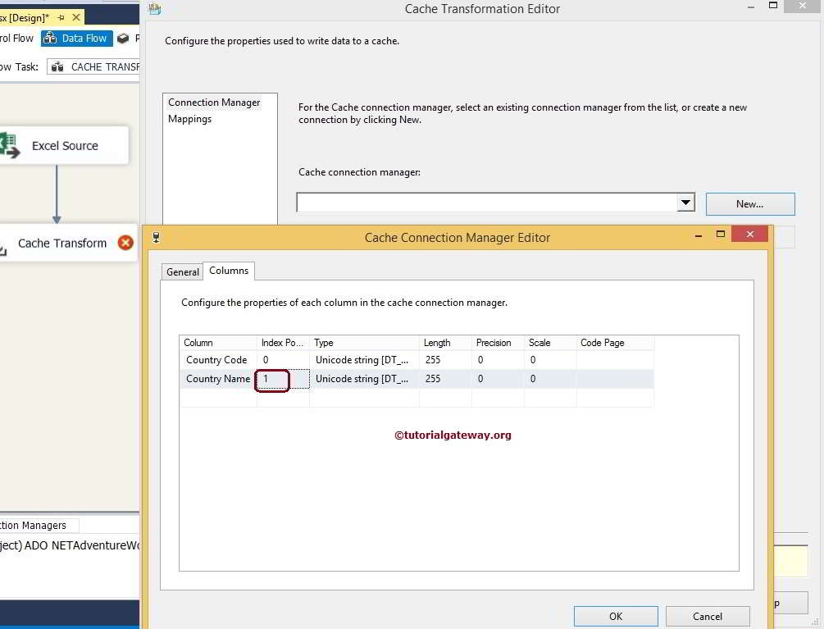

Click ok to finish configuring the SSIS Cache Connection Manager.

**STEP 7:** Click on the columns tab to verify that all the columns mapped exactly or not. If not, please map **Input Columns** with the appropriate **Destination Column.** Otherwise, you will end up with the wrong data.

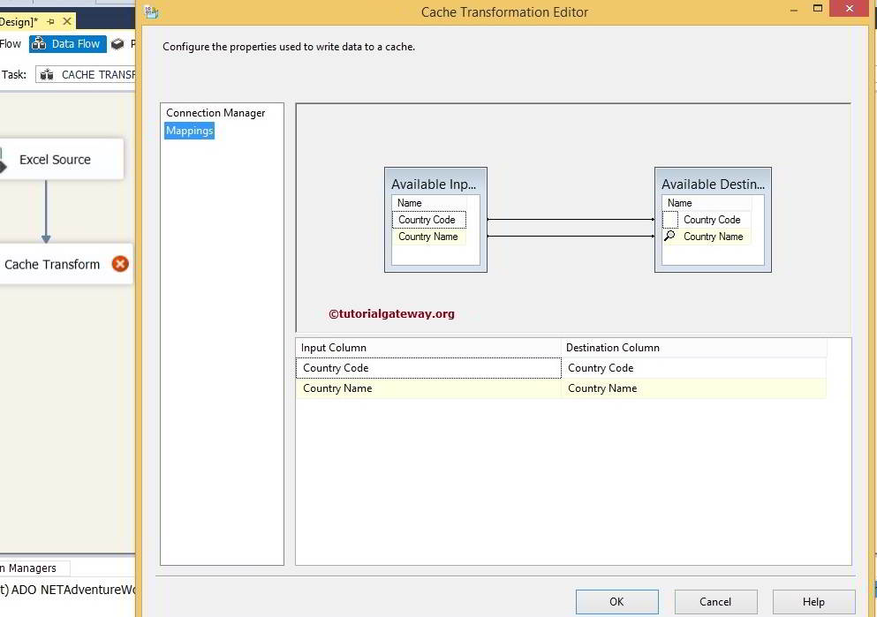

Click ok and run the SSIS Cache Transformation package to create cache file in local drive

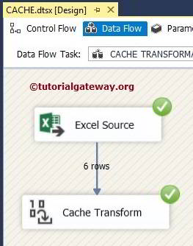

Check the result of the SSIS Cache Transformation

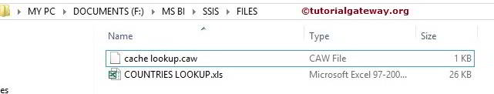

# Lookup in SSIS

The Lookup in [SSIS](https://www.tutorialgateway.org/ssis/) is one of the most useful transformations which is used to compare the source data to the existing data from the reference table (or Lookup Table) and find matching ones. For the non-matching rows, we can further do some more work.

**Case Sensitivity in Lookup Transformation:** Lookup in SSIS is Case-Sensitive, Kana-sensitive, Accent-Sensitive. Lookup Transformation doesn’t matter even if your source and destinations databases setting are case-insensitive. So, if your data is not in the proper case, it is advisable to convert your lookup table and source data to Uppercase or Lowercase. Please refer to the [Lookup Transformation Case Sensitivity](https://www.tutorialgateway.org/ssis-lookup-transformation-case-sensitivity/) article for better understanding.

## Steps involved in configuring Lookup in SSIS

Double click on the Lookup in SSIS will open the Lookup Transformation Editor to configure it. Within the General page, it provides us with the options to set **Cache Mode**, **Connection Type**, and **Specify how to handle rows with no matching entries** options.

[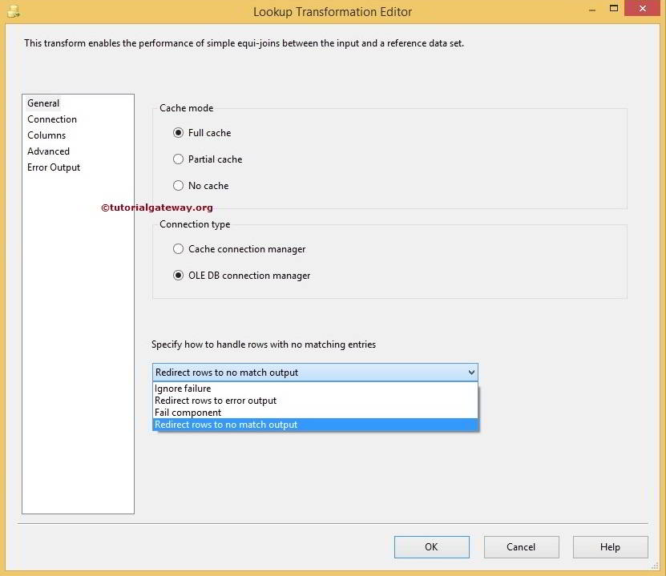](https://www.tutorialgateway.org/wp-content/uploads/SSIS-Lookup-Transformation.jpg)

Lookup in SSIS supports only two types of Connection Managers:

* **OLE DB Connection Manager:** Lookup Transformation uses [OLE DB Connection Manager](https://www.tutorialgateway.org/ole-db-connection-manager-in-ssis/) to access the reference table present in the [SQL Server](https://www.tutorialgateway.org/sql/), Oracle, and DB2. Please refer to [Lookup Transformation in SSIS](https://www.tutorialgateway.org/lookup-transformation-in-ssis/) article to understand, How to configure Lookup Transformation using the OLE DB Connection Manager.
* **Cache Connection Manager:** By default, Lookup in SSIS uses the OLE DB Connection Manager to connect with the reference table. Other sources can use, but they must be used indirectly via a [Cache Transformation](https://www.tutorialgateway.org/cache-transformation-in-ssis/). For example, we can use a Text file or an Excel file as a lookup table using the Cache Connection Manager. Please refer [Lookup Transformation in Full Cache Mode](https://www.tutorialgateway.org/ssis-lookup-transformation-in-full-cache-mode/) article to understand, How to configure Lookup Transformation using the [Cache Connection Manager](https://www.tutorialgateway.org/cache-connection-manager-in-ssis/)

### Lookup in SSIS Cache Mode

You have three options for SSIS Lookup cache mode:

* **Full Cache mode:** This is the most commonly used approach in Lookup Transformation. If we selected this option, the entire lookup (or reference) table would preload into the cache (Memory). And SSIS Lookup Transformation will perform a lookup from the Memory instead of Dataset. It works well when we have less number of rows in the lookup table.
* **Partial Cache mode:** If we selected this option, SSIS Lookup Transformation starts the transformation with an empty cache. When a new row comes from the data flow, the Lookup Transformation first checks for the matching values in its cache. If it not found in the cache, it will check in the lookup table. And if no match found, it queries the lookup table. If the match located in the lookup table, the value cached (stored in the memory) for the next time. If the lookup table is massive, we can use this SSIS approach.
* **No Cache mode:** If we selected this option then, Lookup Transformation will not use the cache to store the lookup table at any stage. When a new row comes from the data flow, the SSIS Lookup directly checks in the lookup table for matching values.

### Error Handling in SSIS Lookup

The final option on this page is to specify, How to handle rows with no matching entries. SSIS Lookup Transformation provides you four options:

* **Fail Component (Default):** When a new row passed from the data flow to lookup. SSIS Lookup will fail the package if it doesn’t find any matching row in the lookup table.
* **Ignore Failure:** If we selected this option, When a new row passed from the data flow, Lookup Transformation would continue its processing even though it doesn’t find any matching row in the lookup table.
* **Redirect Rows to No Match Output:** If we selected this option then, Lookup Transformation will direct the rows that don’t find any matching row in the lookup table to **No Match** In real-time we mostly use this option.
* **Redirect Rows to Error Output:** If we selected this option then, SSIS Lookup Transformation will direct the rows that don’t find any matching row in the lookup table to the standard error output.